Quadratic Equations:
-uses if two numbers have a product of zero then at least once of the numbers must be zero
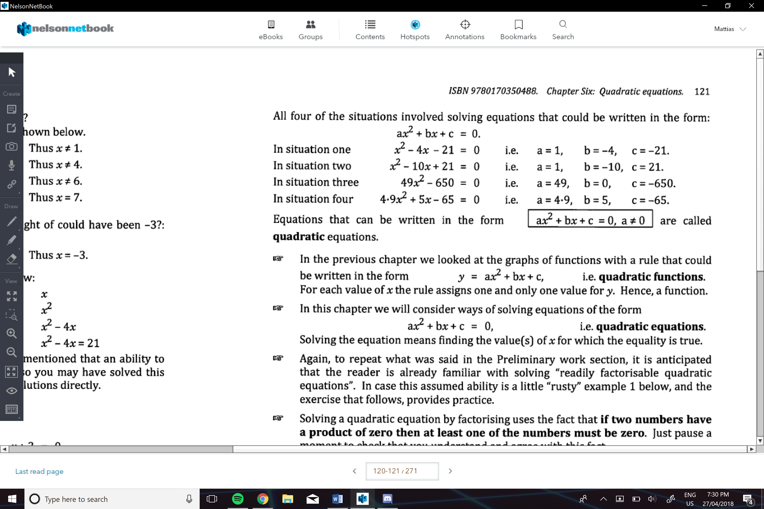
Don’t forget that a square root of a number can be positive or negative
e.g.
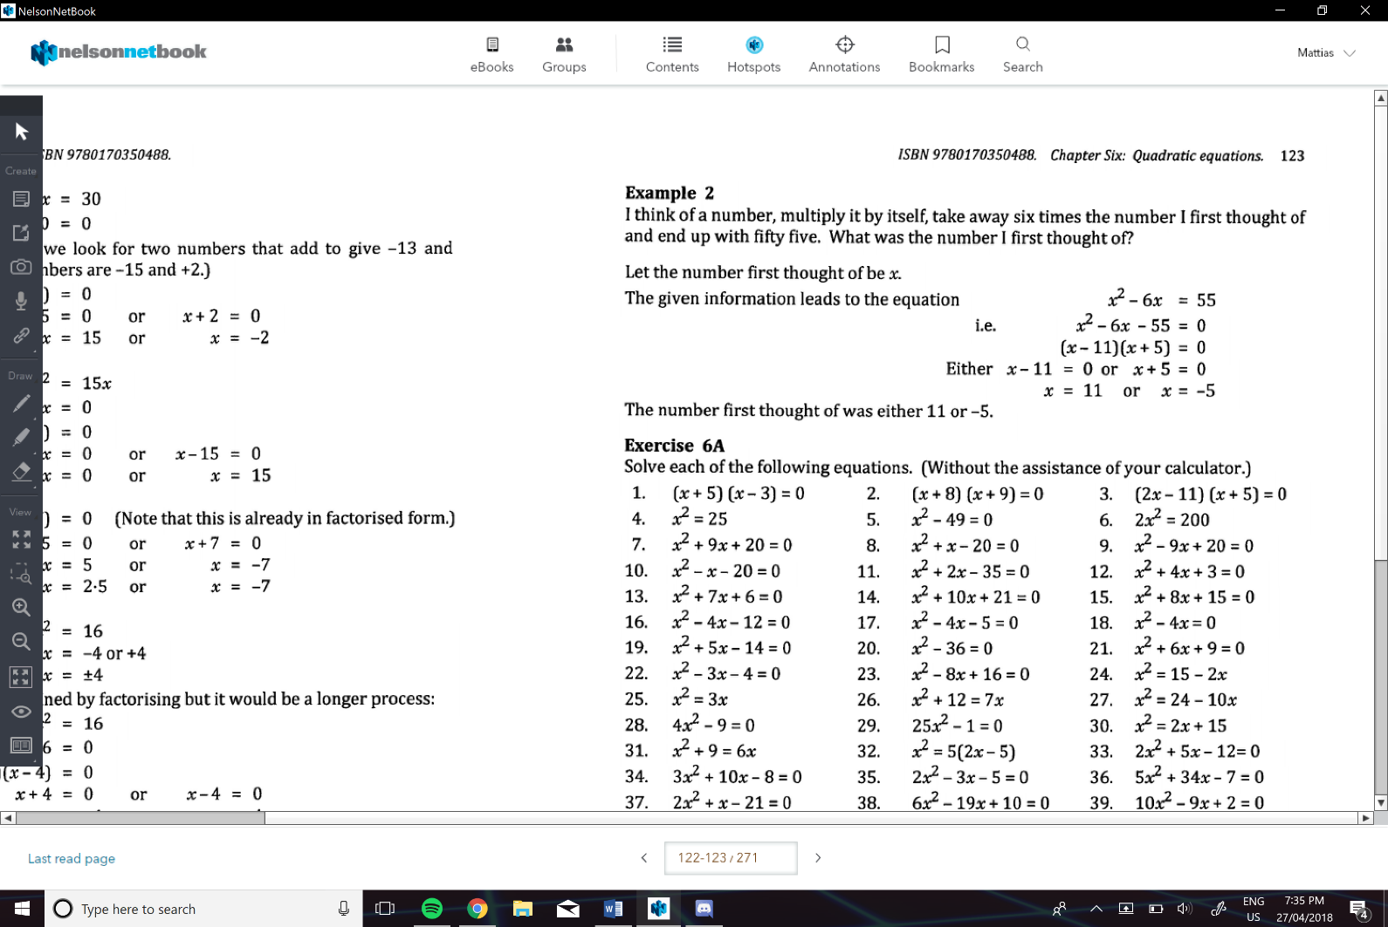
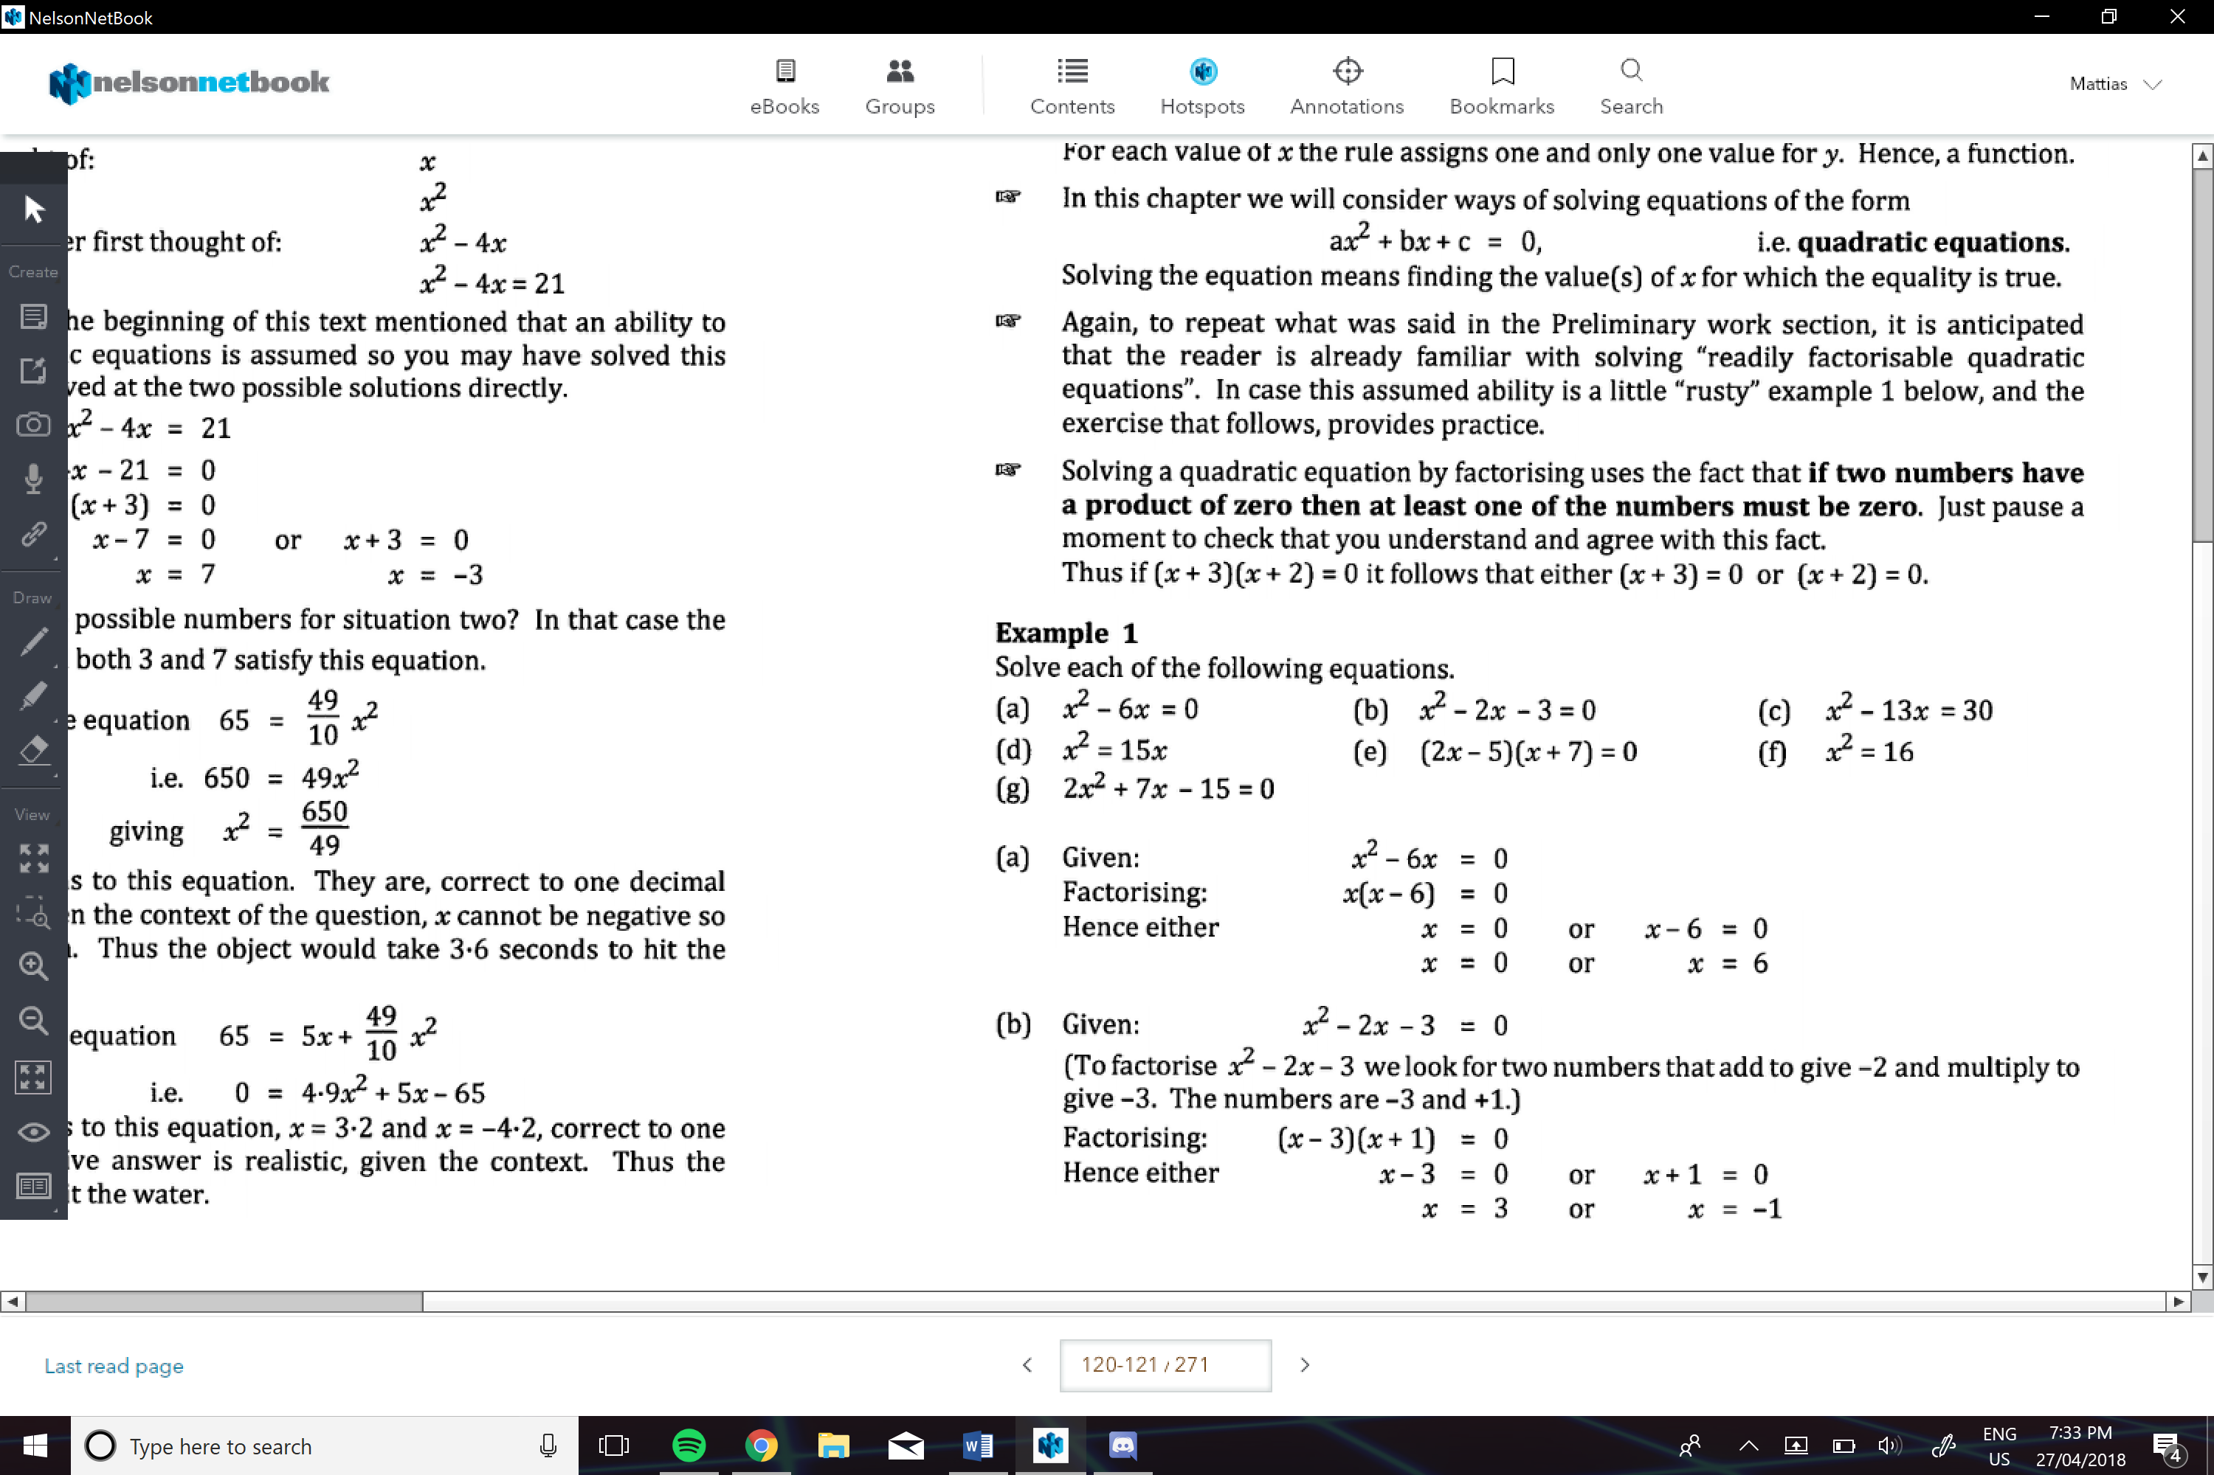
e.g.
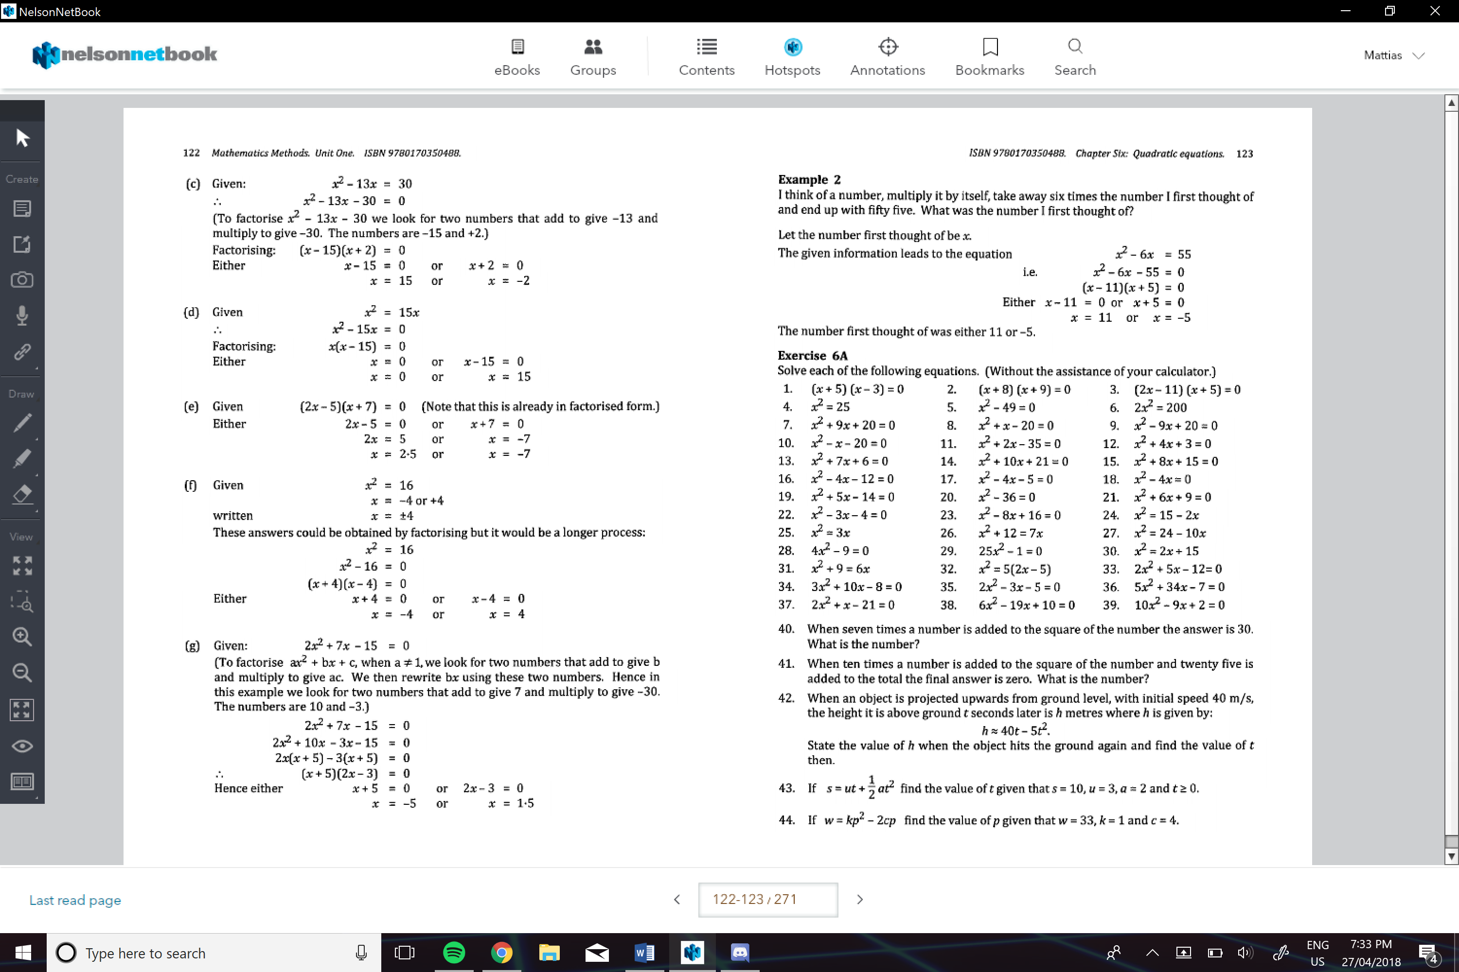
When a quadratic equation is not really factorizable:
We can:
- Use solve on the graphics calculator
- Sketch the graph, and then estimate the values of y and x
- Use completing the square technique
- Or use the formula
Completing the Square Method:
- Move the c to the right-hand side
- Add the square of half the coefficient of x to each side
- Factorise LHS
- Solve
e.g.
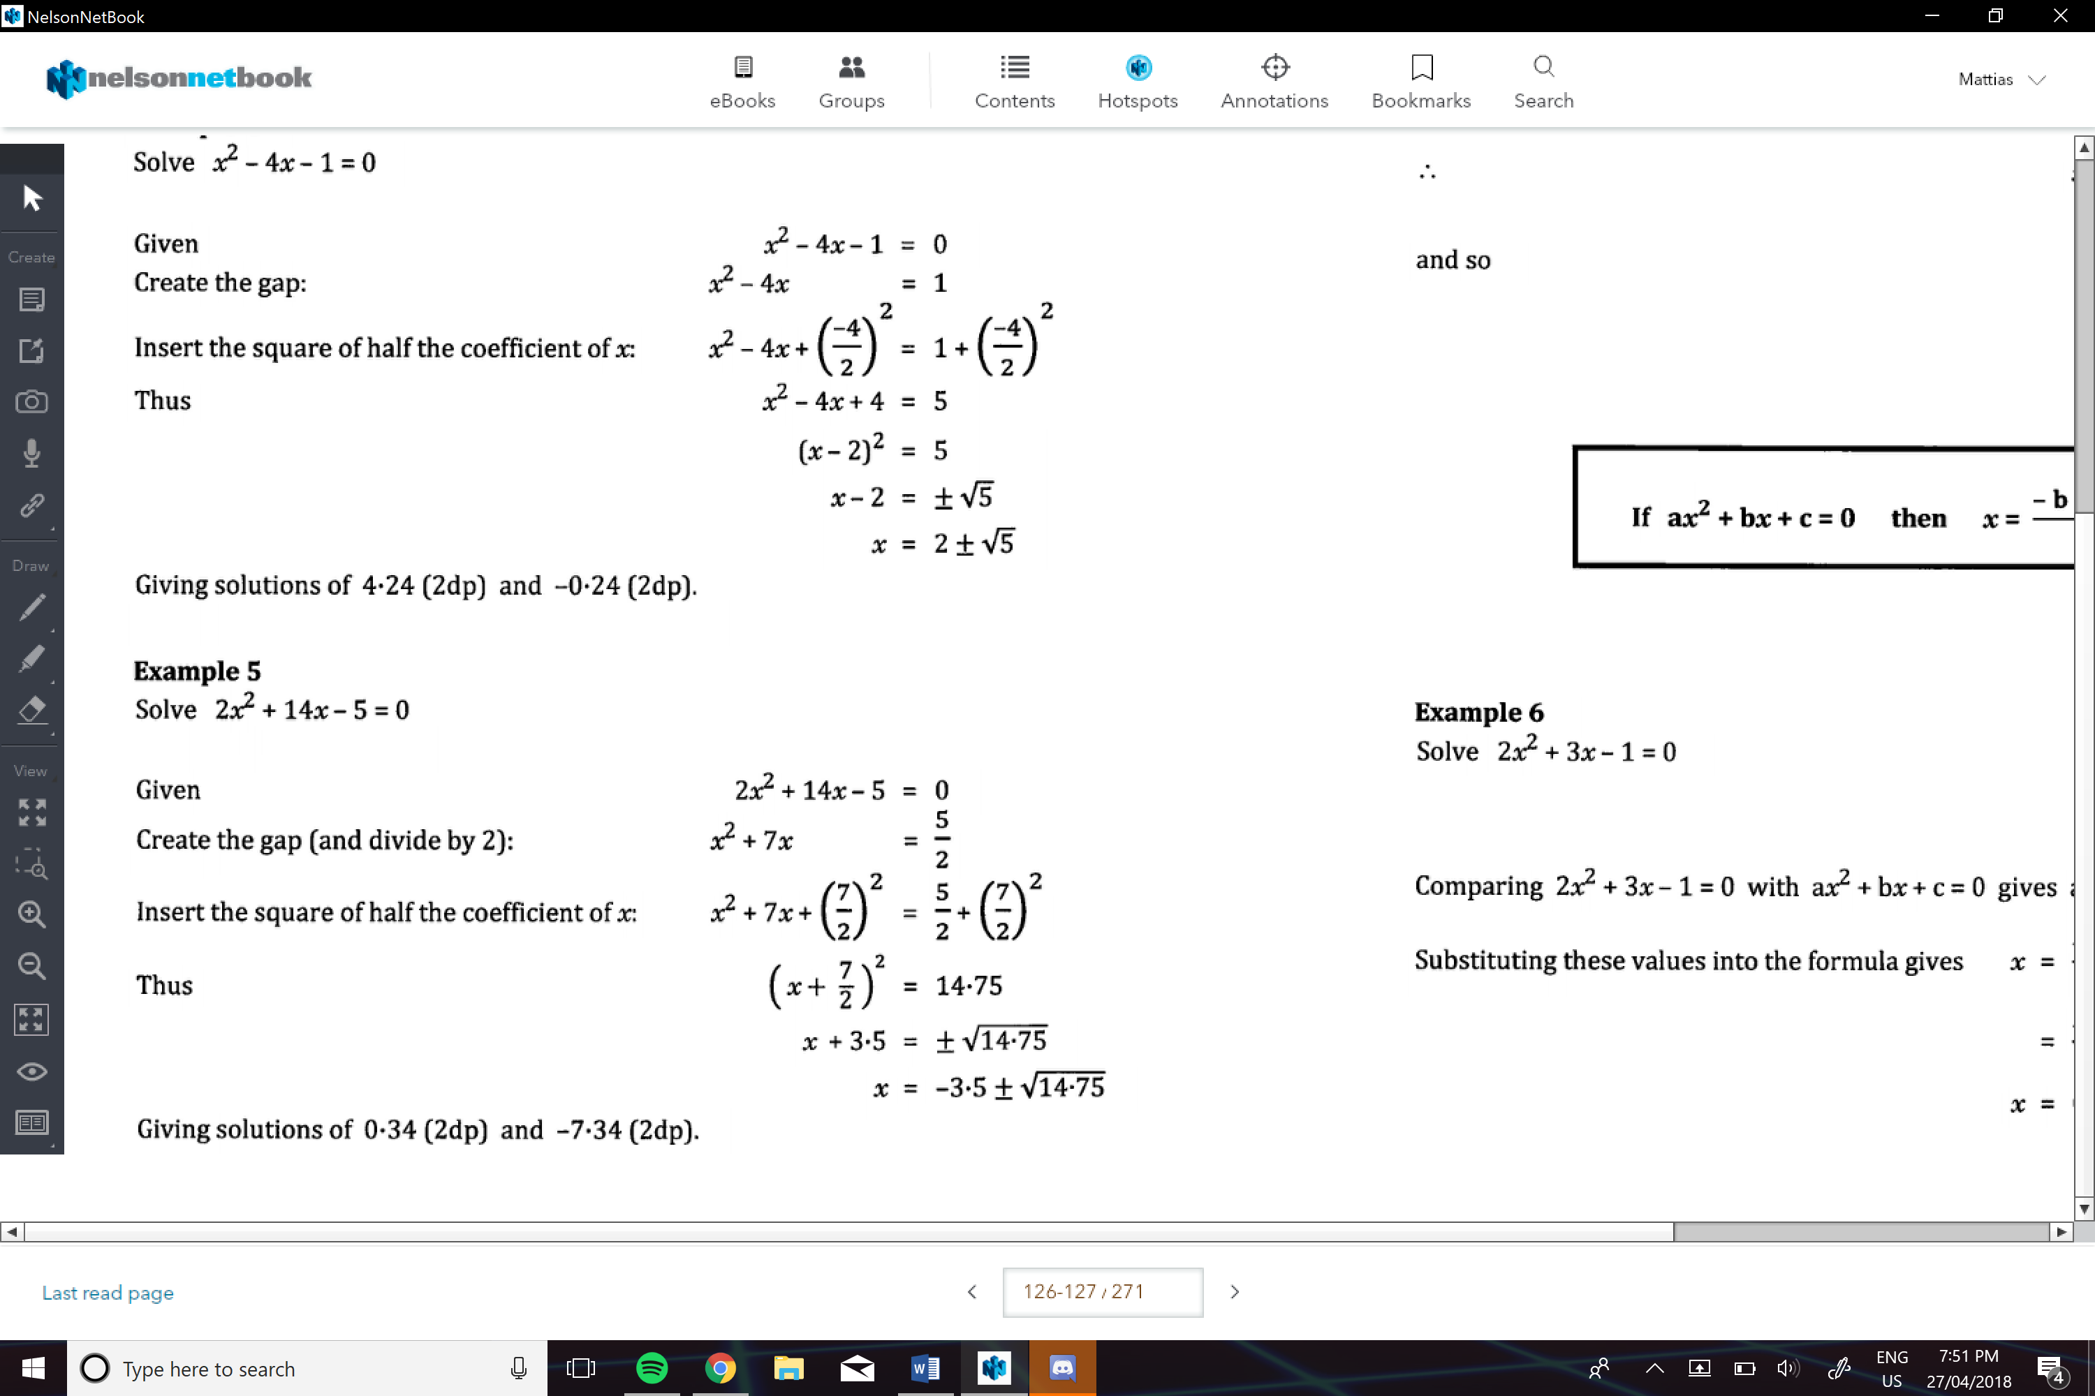
Using the formula:
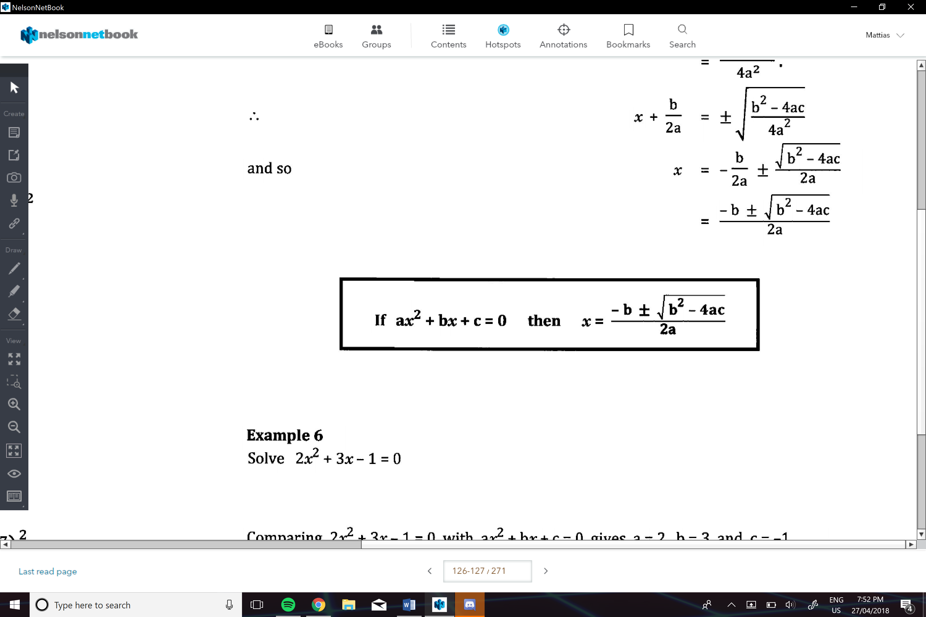
e.g.
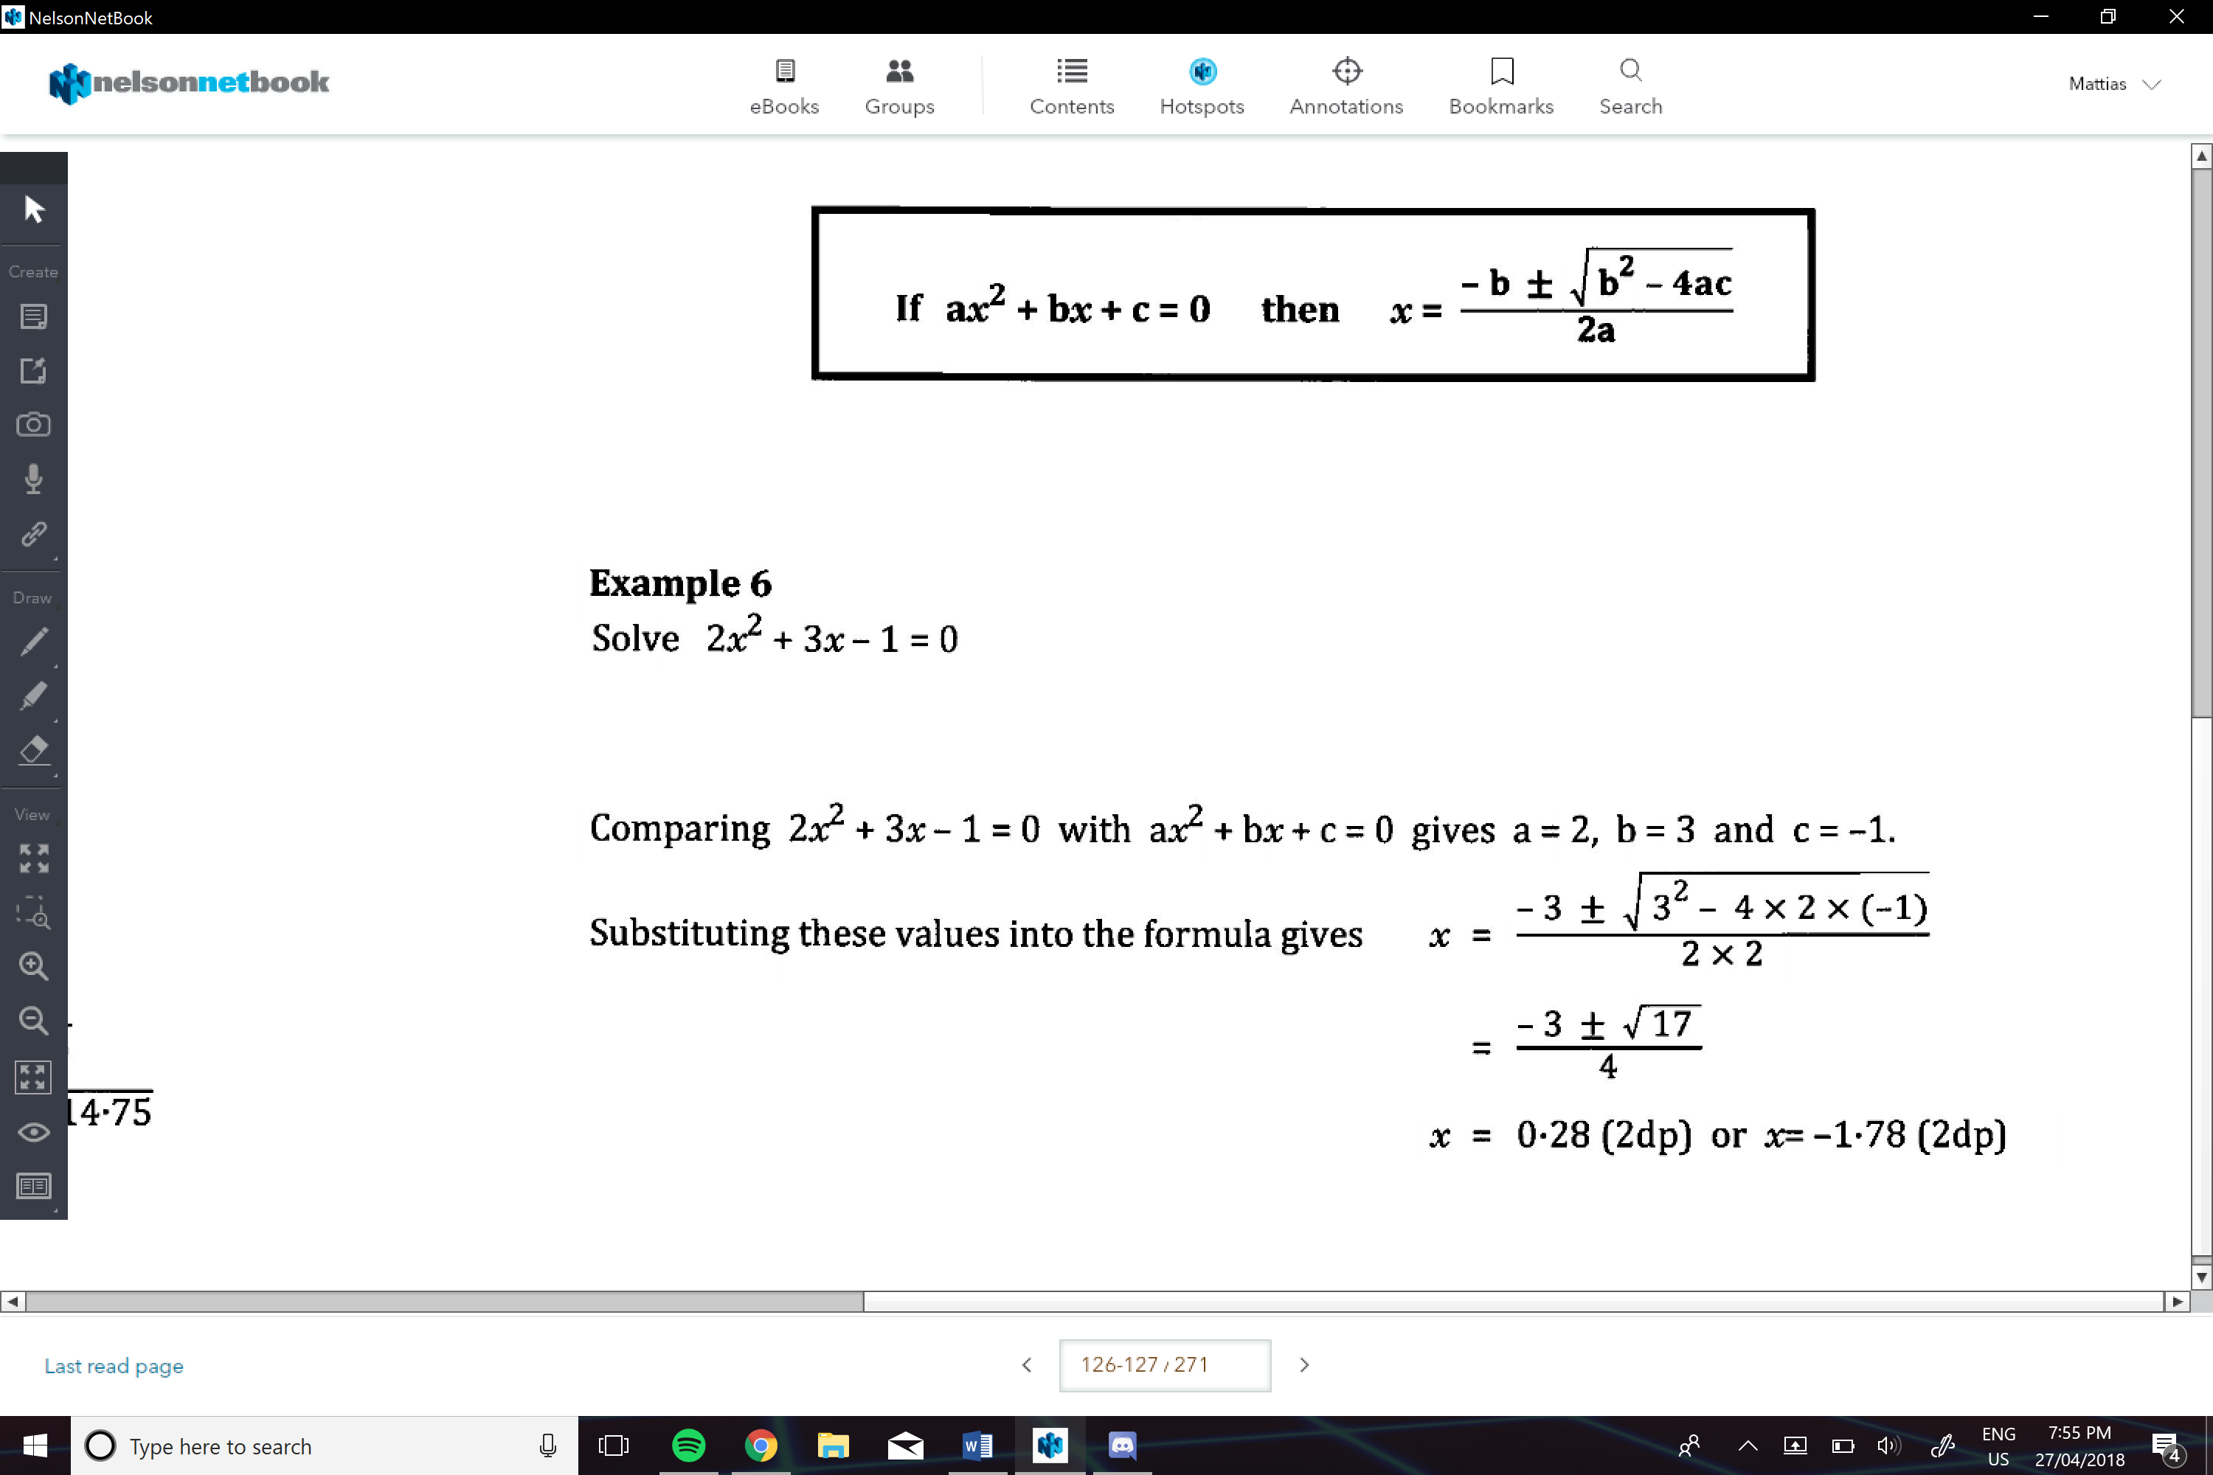
Discriminant:( ∆)
Use to find the number of solutions for x
